PROJECT BUILD & IMPLEMENTATION GUIDE
Automated Network Request Management in ServiceNow
Date | 03 October 2026
Developer / Student | Vinay Krishna A K
Project Name | Automated Network Request Management in ServiceNow

This document covers the complete end-to-end build procedure for the Automated Network Request Management system. It follows a natural, step-by-step creation flow from database schema design to frontend portal configuration, low-code workflow automation, and final testing verification. Each stage details the exact setup instructions along with the specific screenshots required for project evidence submission.

Stage 1: Setting Up the Custom Table (u_database_table)
Before building forms or workflows, I needed a dedicated place to store every network request cleanly without cluttering default tables like Incident. For this, I created a custom table called Database Tables (u_database_table).
I navigated to All > System Definition > Tables and clicked New. In the Table Label field, I entered Database Tables, and ServiceNow automatically generated the name u_database_table. To ensure every request receives a unique tracking identifier, I navigated to the Controls tab, enabled Auto-number, set the prefix to DBT, and selected 7 digits. This automatically formats records as NETDB0001009.
In the Columns tab, I added the fields required to hold form inputs and track request progress:
- Requester Profile: Requested For (Reference to sys_user), Opened on behalf of (Reference to sys_user), and User Name (String).
- Contact Information: Phone Number (String), Mobile Number (String), and Email ID (String) for sending automatic notifications.
- Network Details: Type of Connection (Choice: New, Existing) and Existing ID (String) to capture existing port or line numbers.
- Billing & Location: Total Amount (Decimal), Mode of Payment (Choice: UPI, Card), and Address (Multi-line String, 4000 chars) for workstation delivery.
- Lifecycle State: State (Choice: Awaiting Approval, Approved, Rejected) to track the request throughout the workflow.
I saved the table and verified that default Access Control Lists (ACLs) were created, granting read access to requesters and full control to administrators.
Screenshot 1: Custom Table & Auto-Number Setup
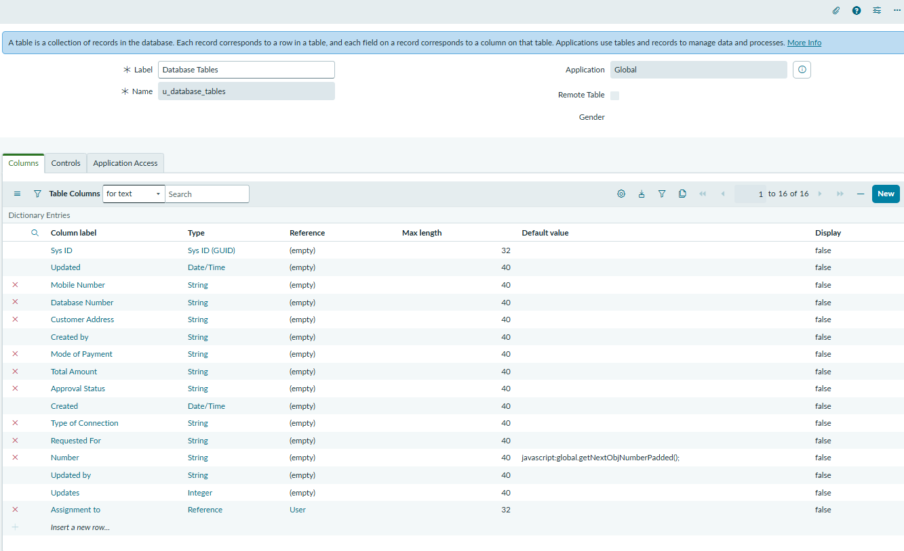
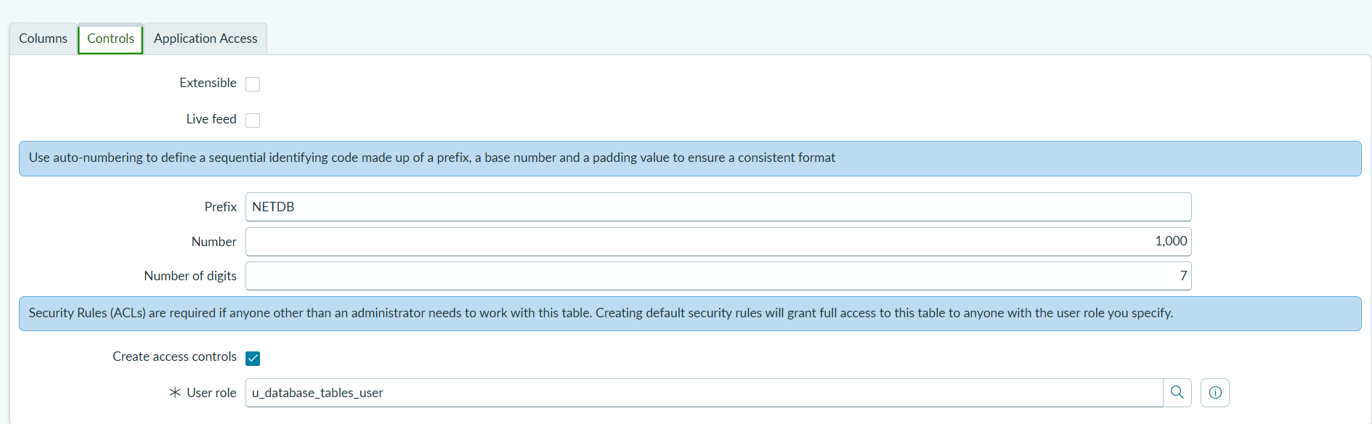

Stage 2: Building the Service Catalog Item & Dynamic Form Rules
With the database table in place, I configured the user-facing request item in the Service Catalog. To keep the form intuitive and avoid human error, I added dynamic rules so conditional fields only show up when relevant.
I navigated to Service Catalog > Catalog Definitions > Maintain Items and clicked New. I titled the item Network Request and categorized it under Network request Management. In the Variables tab, I created all 7 variables matching the custom table fields
To handle conditional visibility without writing custom client scripts, I opened the Catalog UI Policies tab and clicked New. I set the condition to Type of Connection is Existing, leaving On Load = True and Reverse if false = True. Under Catalog UI Policy Actions, I targeted existing_id and set Make Visible = True and Make Mandatory = True. This keeps the Existing ID field hidden for new connections while enforcing it whenever an existing connection is selected.

Screenshot 2: Service Catalog Item Configuration
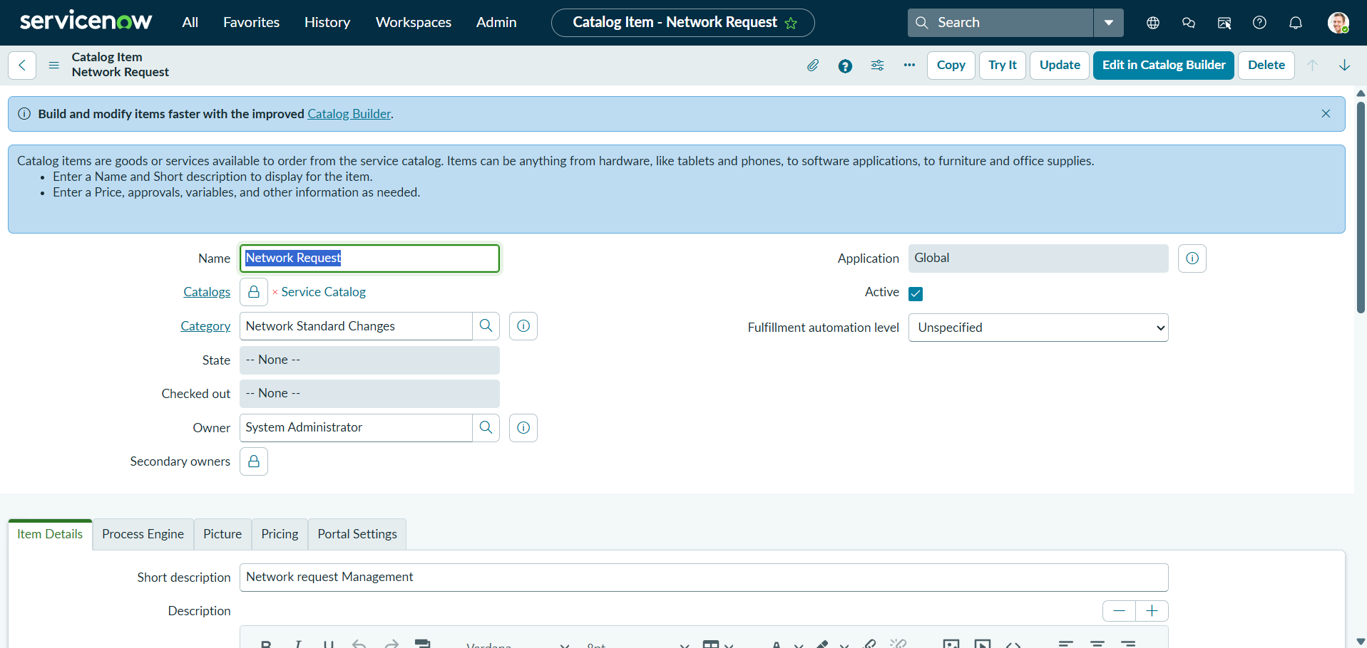
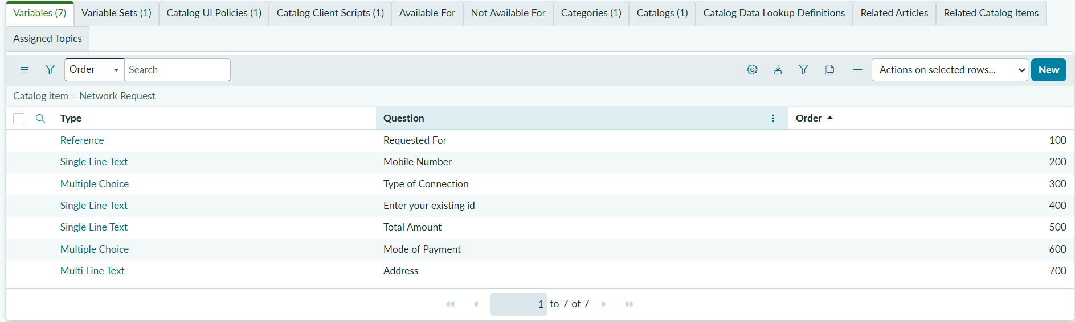

Screenshot 3: Dynamic Catalog UI Policy Rule
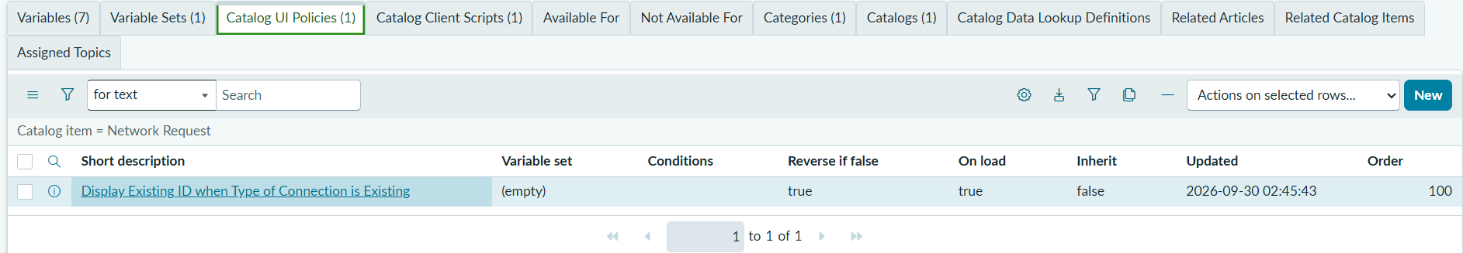
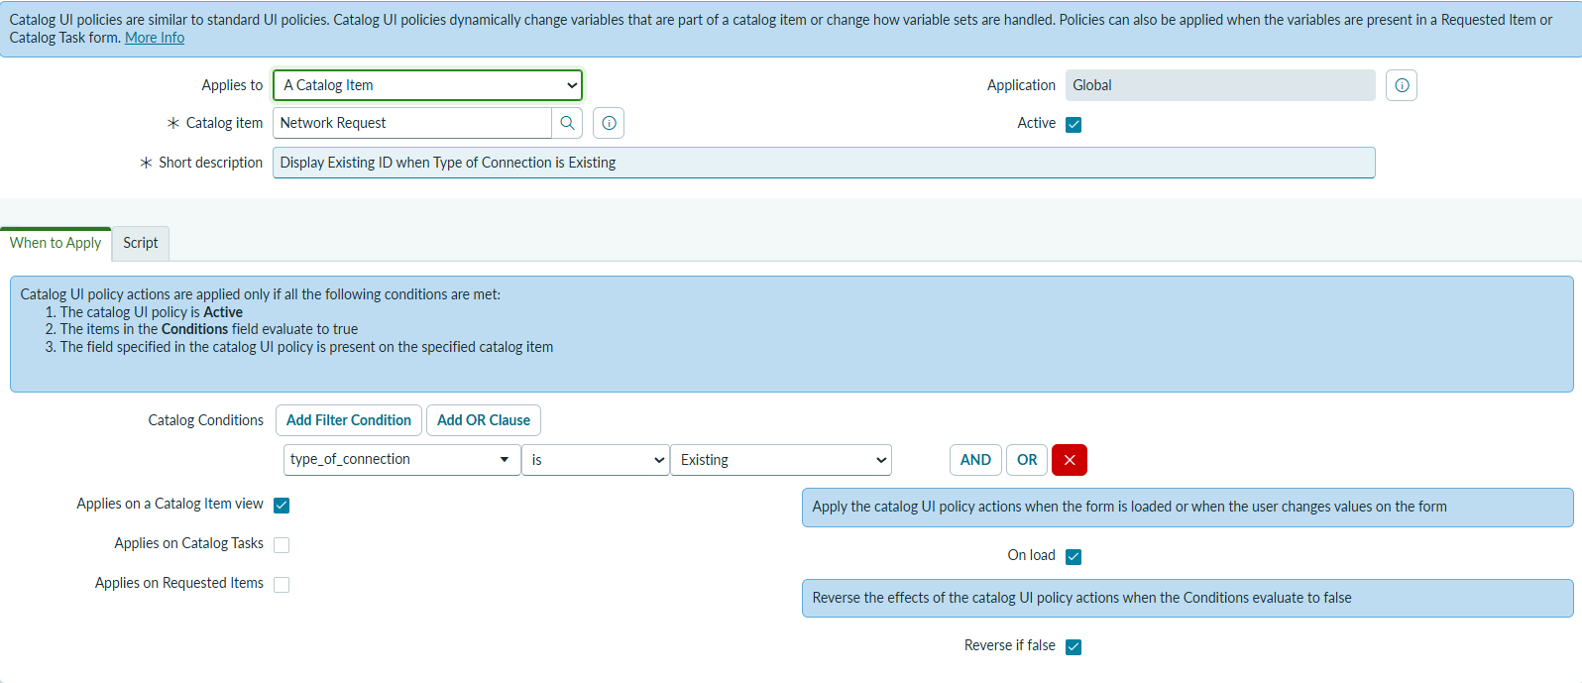

Stage 3: Testing the Service Portal Intake (/sp)
To make sure everything worked as expected from an end-user standpoint, I opened the ServiceNow Service Portal (/sp) and performed a live test submission.
I opened the portal at /sp, typed Network Request into the search bar, and opened the catalog item. I verified that my contact details were loaded properly, then tested the UI policy by toggling the connection type: clicking Existing immediately revealed the mandatory Existing ID field without refreshing the page. I filled in the required values, picked UPI as the payment mode, entered the total fee, typed the delivery address, attached a verification file, and clicked Submit.
Screenshot 4: Service Portal Catalog Item Search
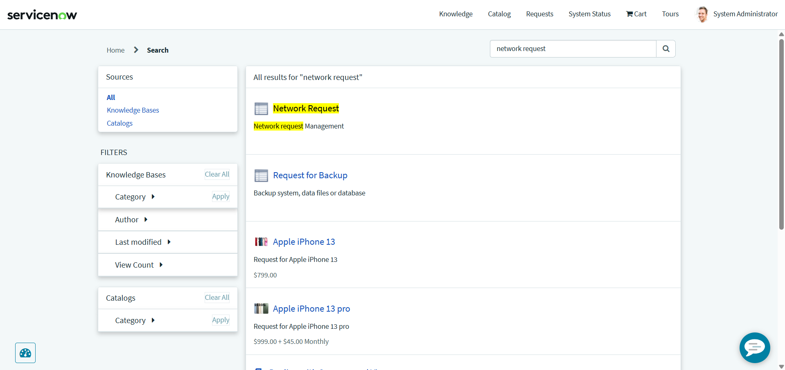
Screenshot 5: Network Request Portal Form (Initial Intake View)

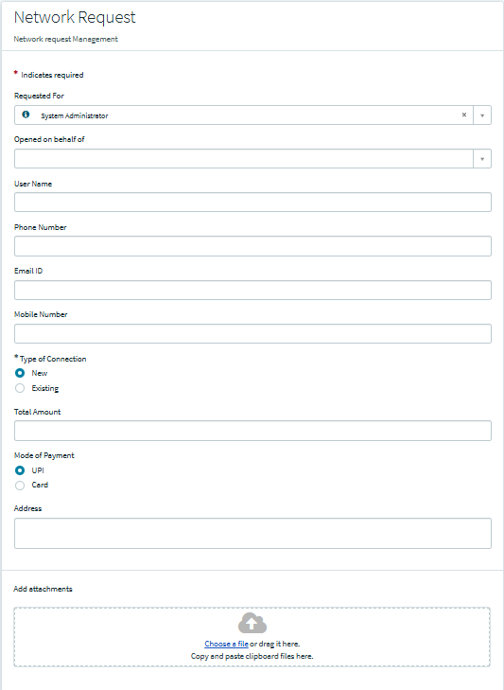

Screenshot 6: Dynamic UI Policy in Action (Existing ID Revealed)
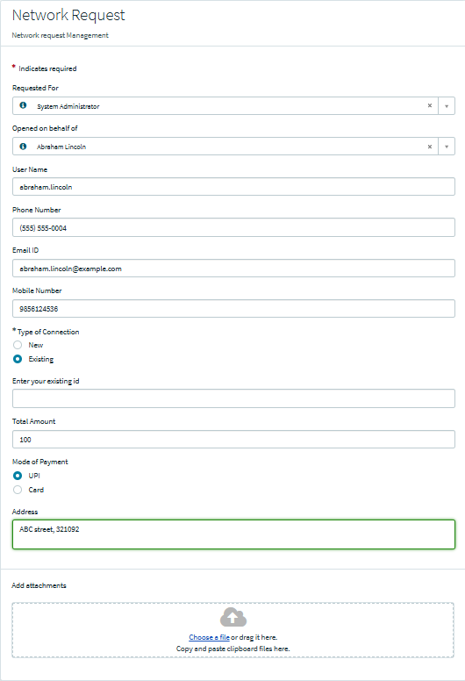

Screenshot 7: Request Submission Confirmation
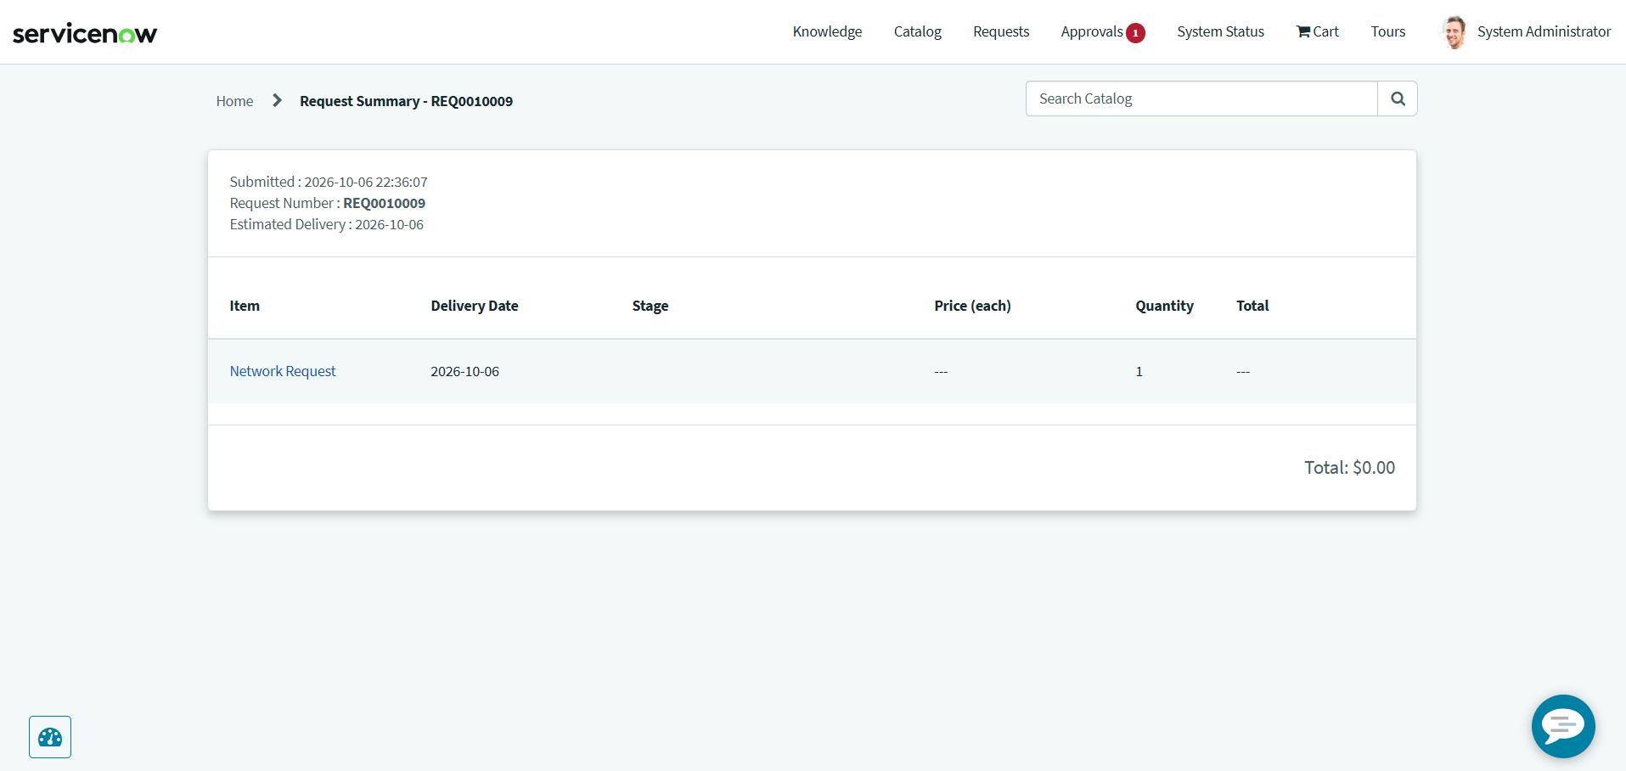

Stage 4: Building the 10-Step Flow Designer Workflow
Once the Service Portal form was ready, I automated the backend processing in Flow Designer without writing scripts. The 10-step flow captures form variables, inserts a custom record, handles manager approvals, and routes conditional outcomes.
- Trigger: Service Catalog — Starts automatically upon catalog item submission.
- Step 1: Get Catalog Variables from Network Request — Loads submitted form values into data pills.
- Step 2: Create Database Tables Record — Inserts a record into Database Tables (u_database_table) with the captured variables.
- Step 3: Send Email — Sends an immediate confirmation email with the tracking reference to the user.
- Step 4: Ask For Approval on Database Tables — Generates an approval task and assigns it to the manager.
- Step 5: If: If Request is Approved — Checks if the approval state is Approved.
  - Approved:
    - Step 6: Update Database Tables Record — Sets record state to Approved.
    - Step 7: Send Email — Sends an approval confirmation email to the user.
  - Rejected:
    - Step 9: Update Database Tables Record — Sets record state to Rejected.
    - Step 10: Send Email — Sends a rejection notice email to the user.
After verifying the logic with Test Flow, I clicked Activate so every new portal submission executes this automation automatically.

Screenshot 8: Flow Designer 10-Step Workflow Canvas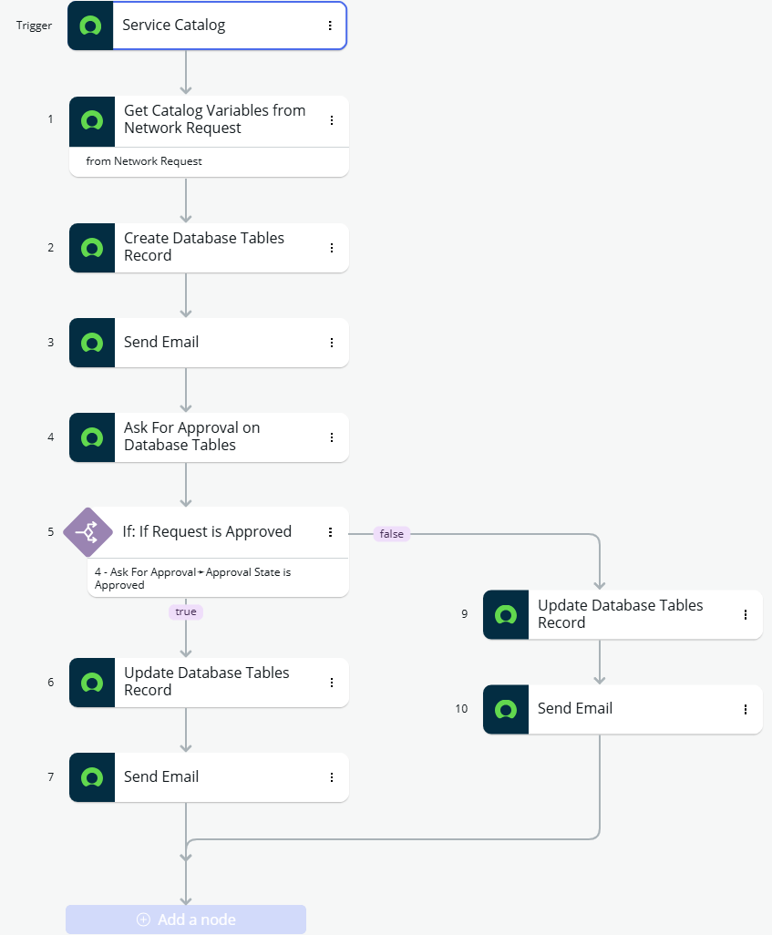
Screenshot 9: Flow Execution Details (Runtime Traces)
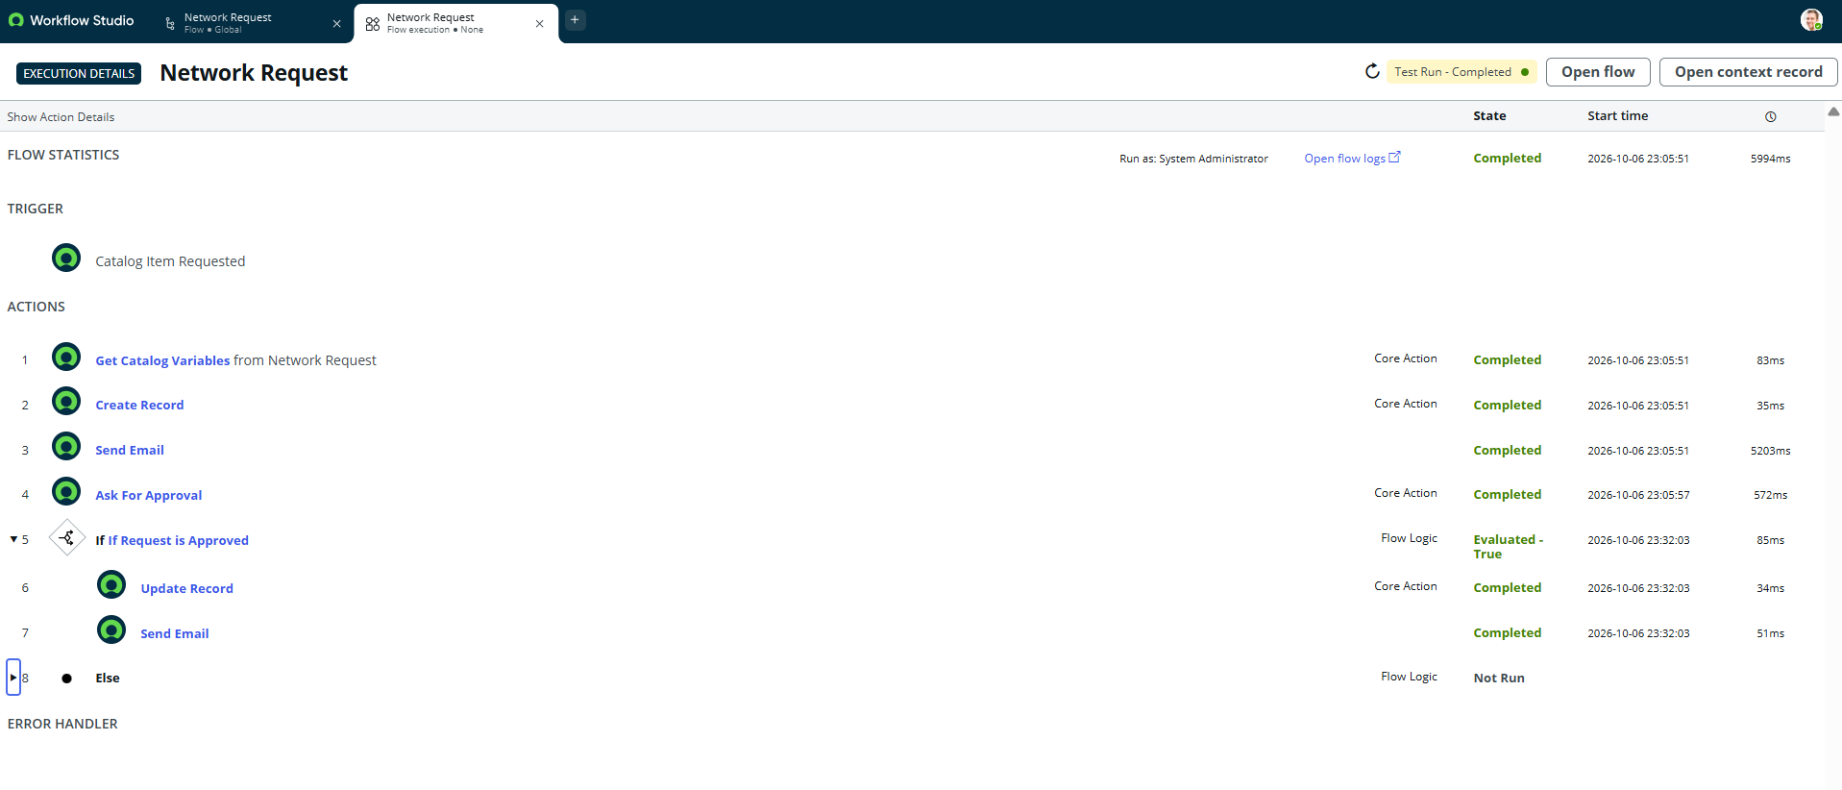

Stage 5: Data Persistence, Governance & Notification Verification
The final stage was verifying that submitted tickets persist properly in our custom table, integrate with platform approvals, and trigger outbound notifications.

Here is how I verified each component:
1. Database Record Check: In database list verified that submitting the portal form created a row with auto-generated ID NETDB0001009 and initial state Awaiting Approval, correctly saving all user, payment, and address values.
2. Approval Gate Execution: In sysapproval_approver_list.do, verified that Step 4 created an approval task for the manager. Approving it immediately shifted the database record state to Approved via the flow's true branch.
3. Email Delivery Audit: In email list, confirmed two outgoing emails were sent: the initial submission receipt with the tracking ID (Step 3) and the approval notice (Step 7).
4. Security ACL Verification: Verified table ACLs by impersonating an end user, confirming requesters can only view their own submissions while admins retain full write access.

Screenshot 10: Database Tables Record View (u_database_table)
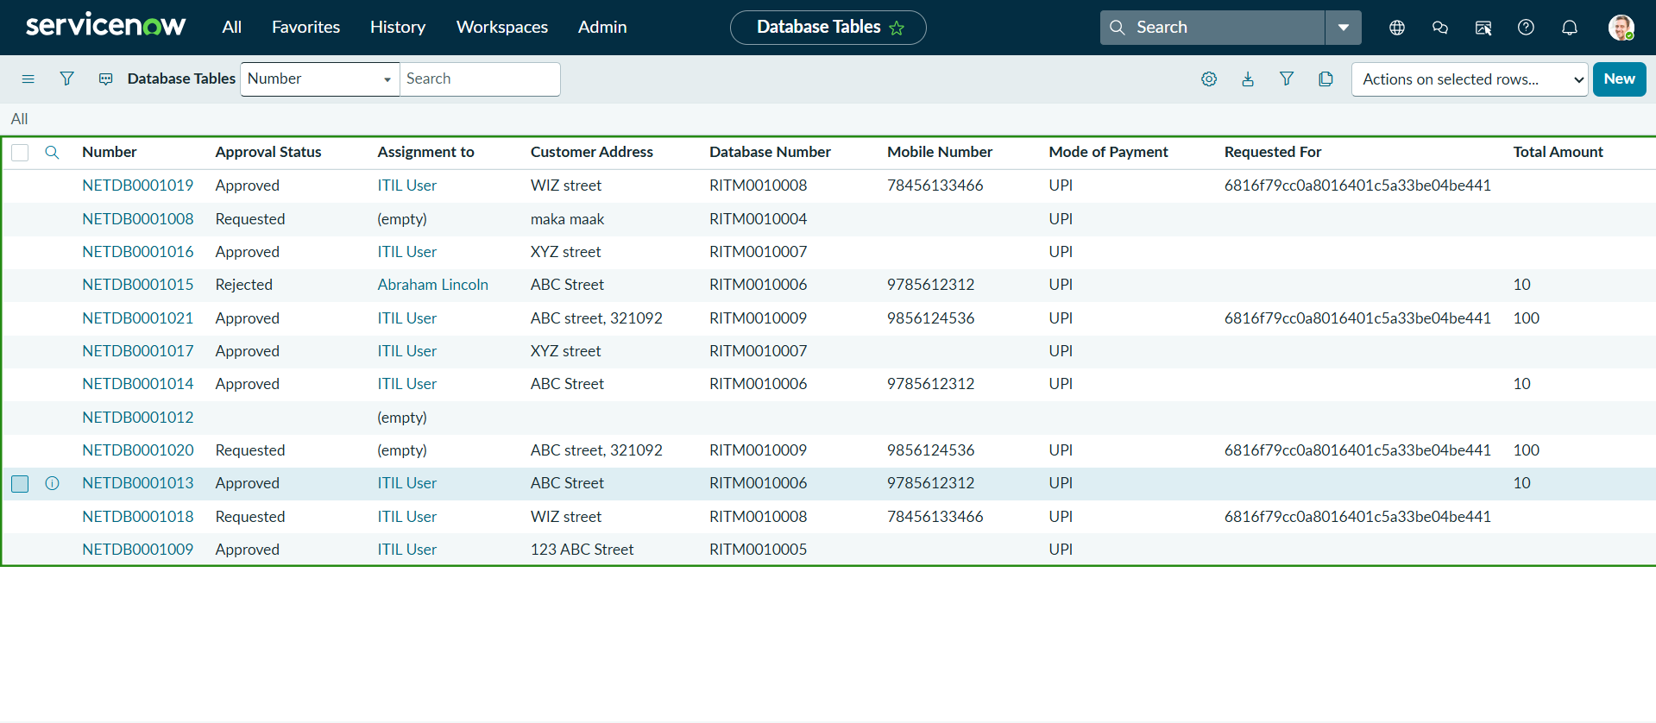

Screenshot 11: Approval Gate Record (sysapproval_approver)
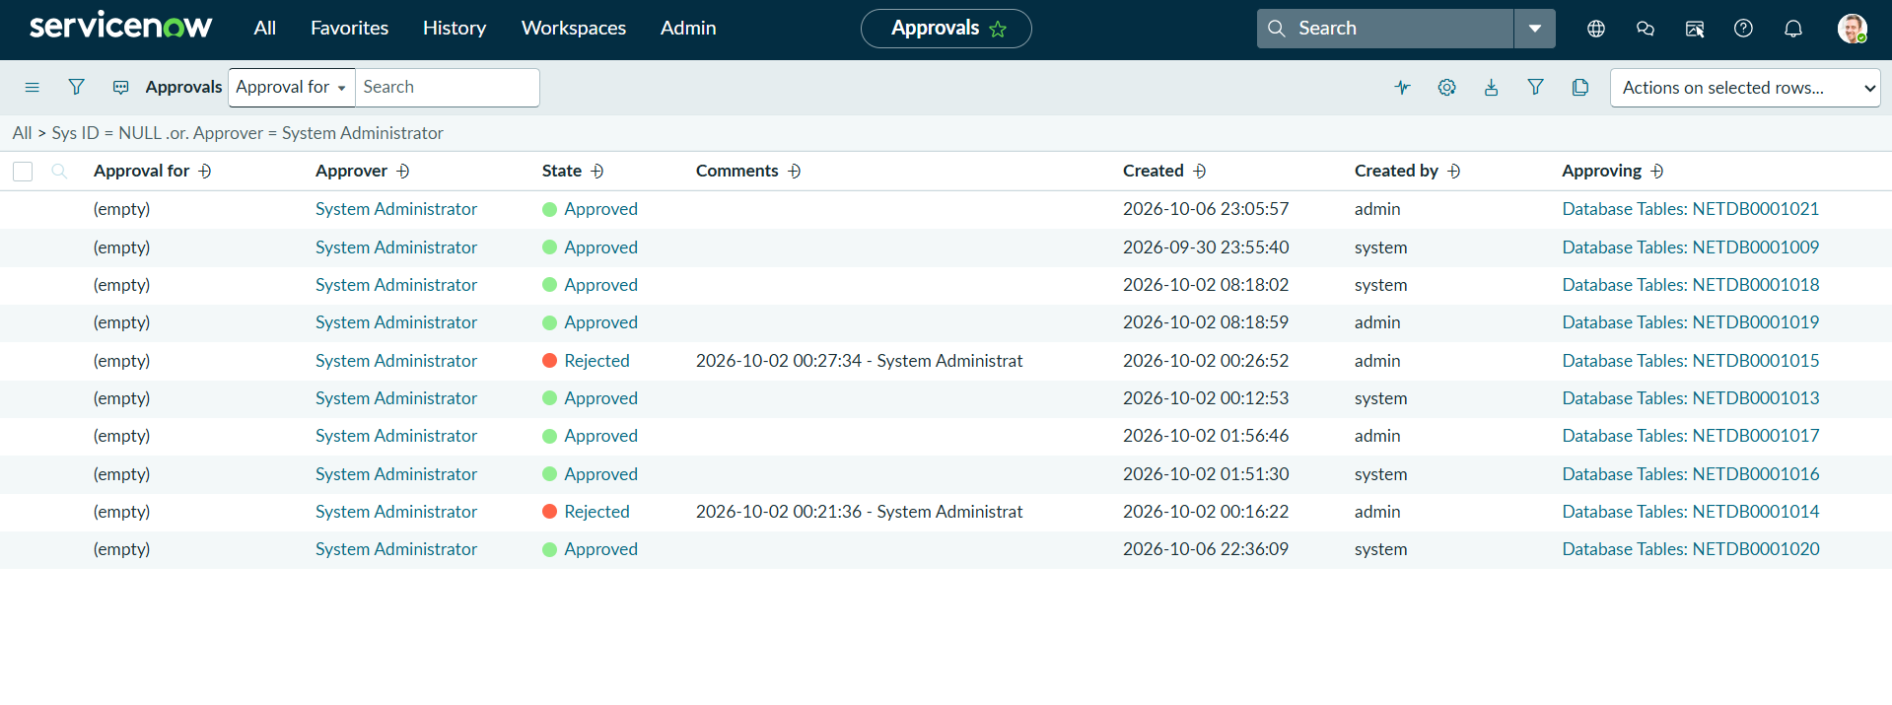

Screenshot 12: Outbound Email Notification Logs (sys_email)
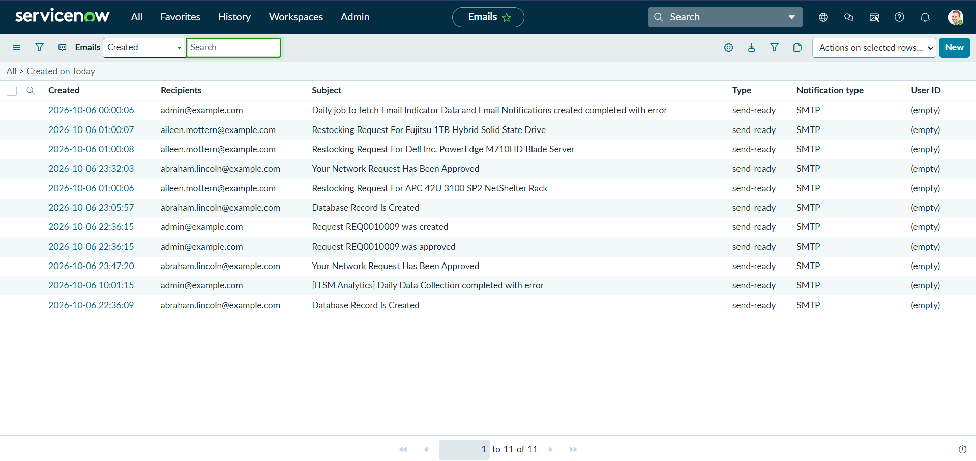
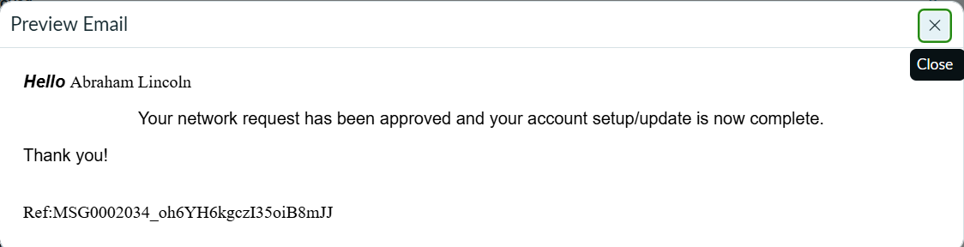

Screenshot 13: Table Access Control List (ACL) Rules
